S-CAB Throttle
Quick Start Guide
The Stanton Radio CAB is a hand-held wireless controller for operating several locomotives on small to medium sized layouts. It is battery powered, and includes a radio transmitter, which transmits DCC commands directly to radio-equipped decoders installed in vehicles, usually locomotives.
A starter package includes an S-CAB, one radio-ready decoder and a USB cable. When delivered, the S-CAB’s battery will be charged and the unit is ready for immediate use.

The Radio CAB

To start S-CAB:
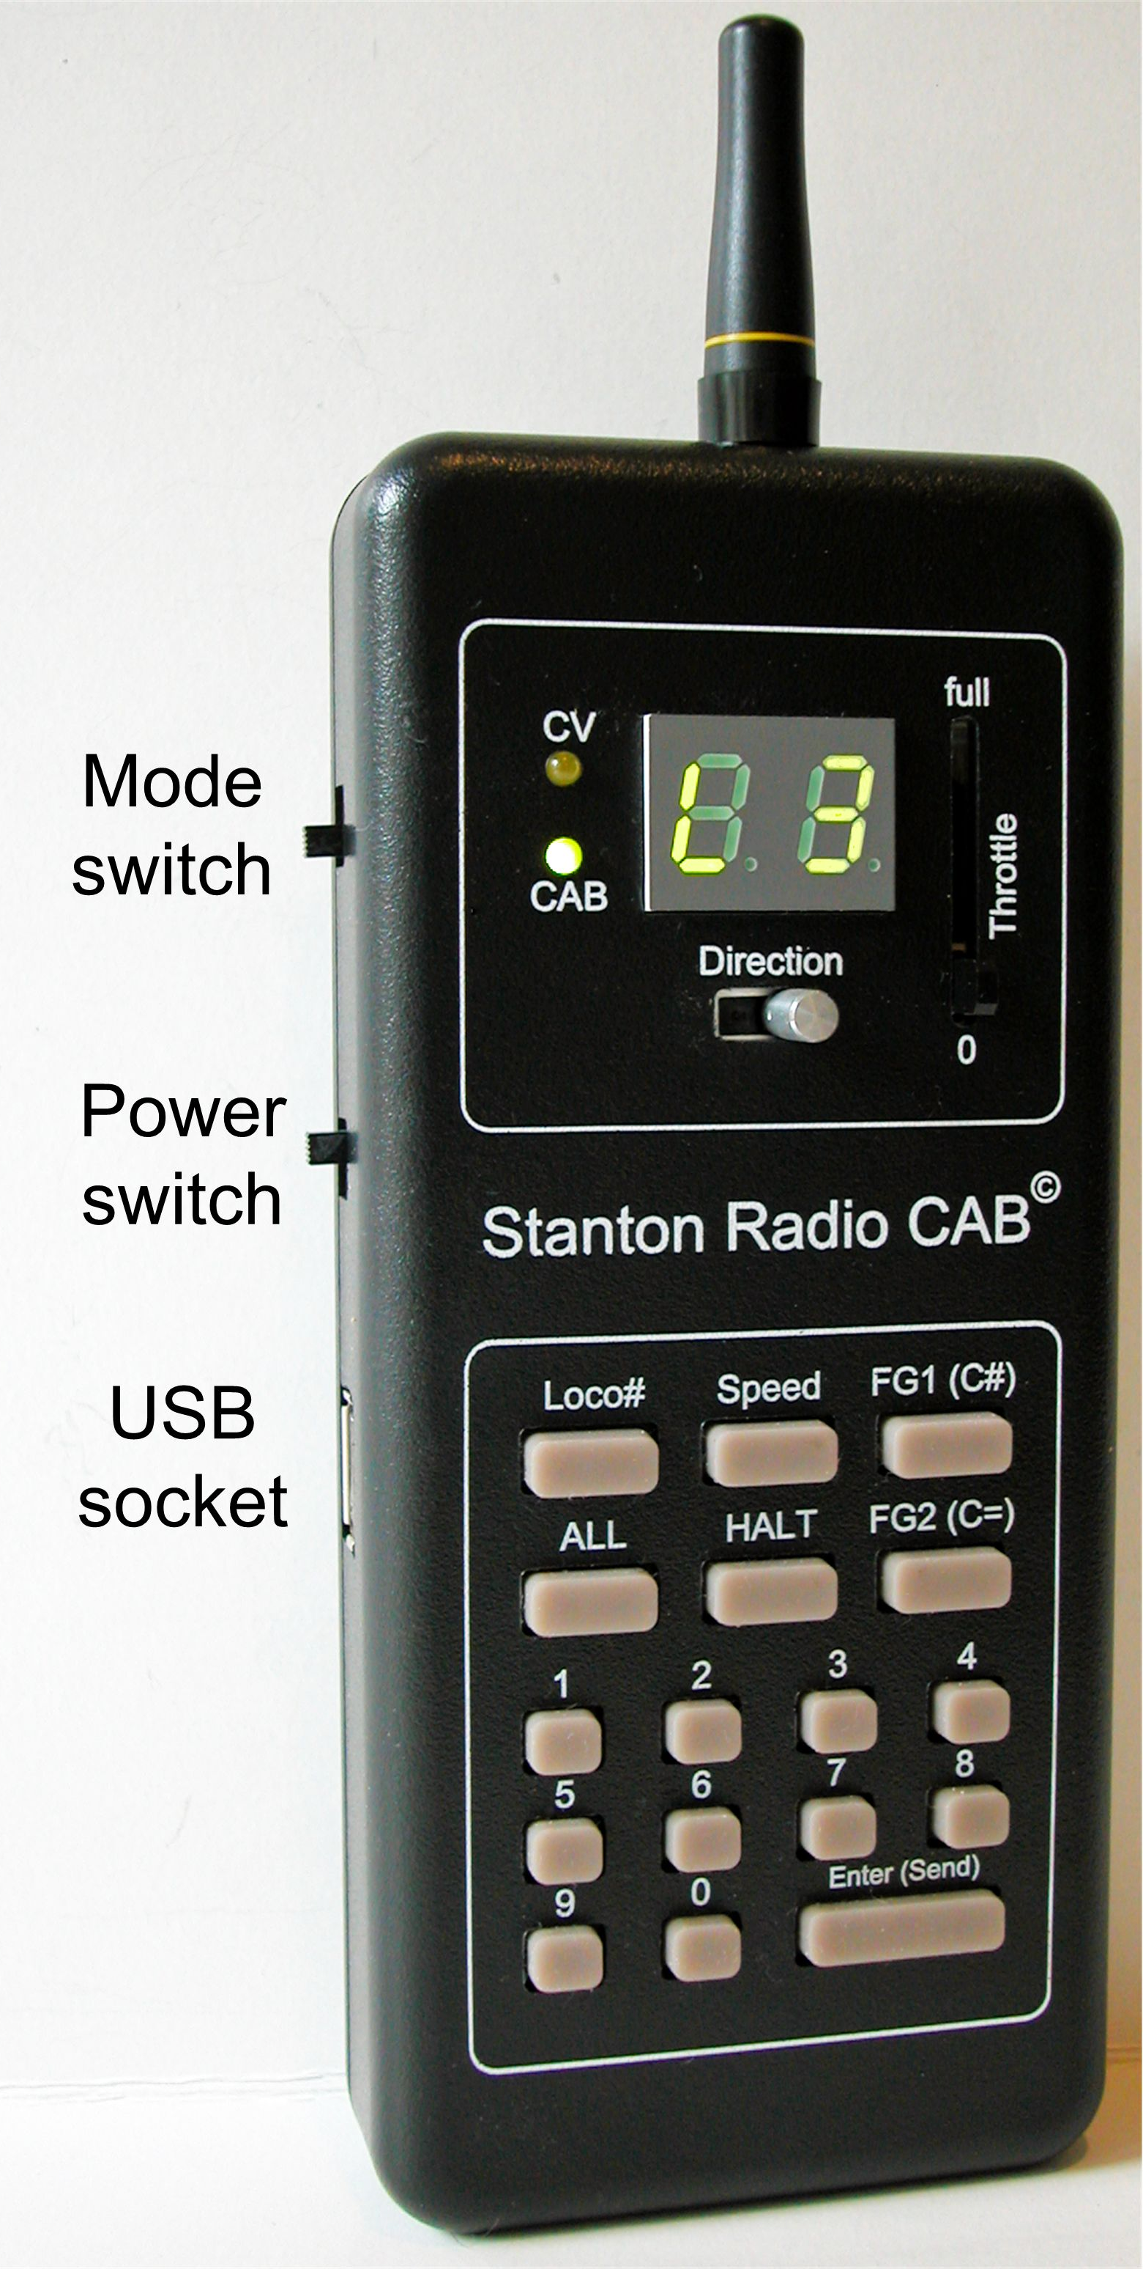
- Move the throttle to zero.
- Put the Mode switch in its CAB position.
- Turn on the Power switch.
What you should see:
- If the ‘CAB’ light is green and the display shows ‘L3’, you’re ready to send commands to decoder number 3, which was included in the starter package.
- If the display shows ‘P’ followed by a number or just shows a 2-digit number, the throttle is not at zero.
- If the CAB light is off and the CV light (yellow) is on, the display will show ‘C’ with a blank second digit. Move the Mode switch down to its CAB position.
- If the display (especially the right-most digit) is not bright, the battery may require charging. Plug in the USB cable and connect to a USB socket on your computer. If you don’t have a computer with USB, buy an inexpensive powered USB Hub. It will only be used as a power source to charge S-CAB’s battery.

Radio-Ready Decoder
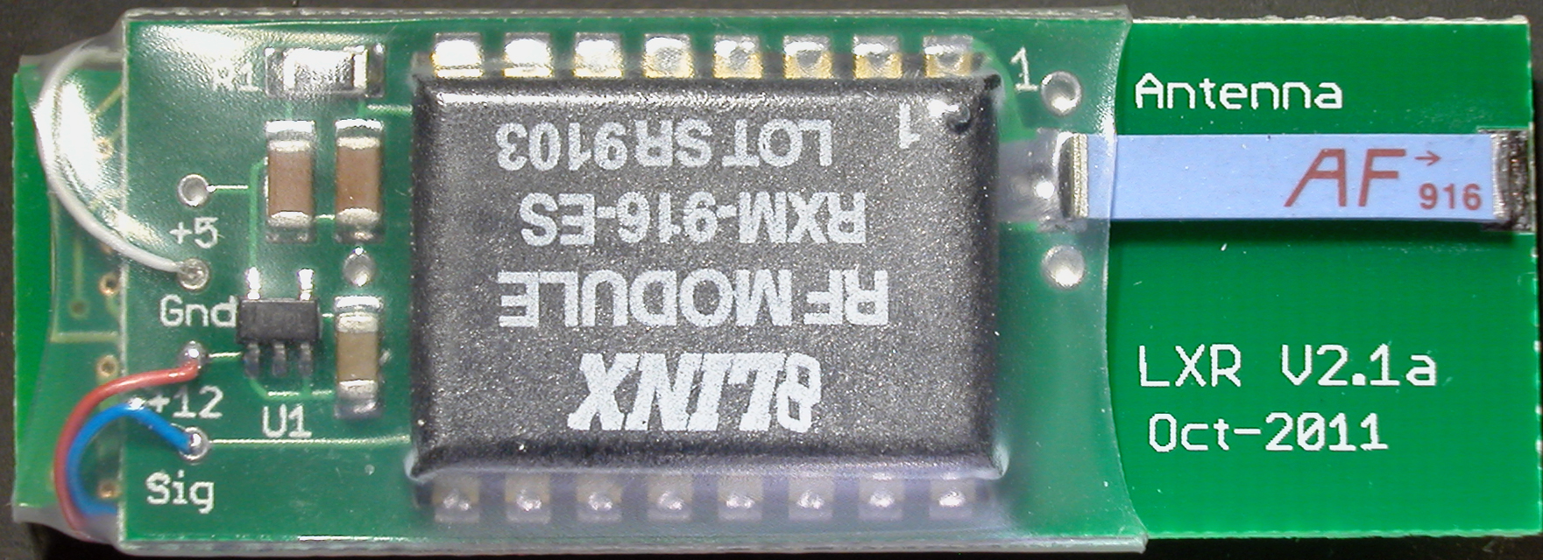
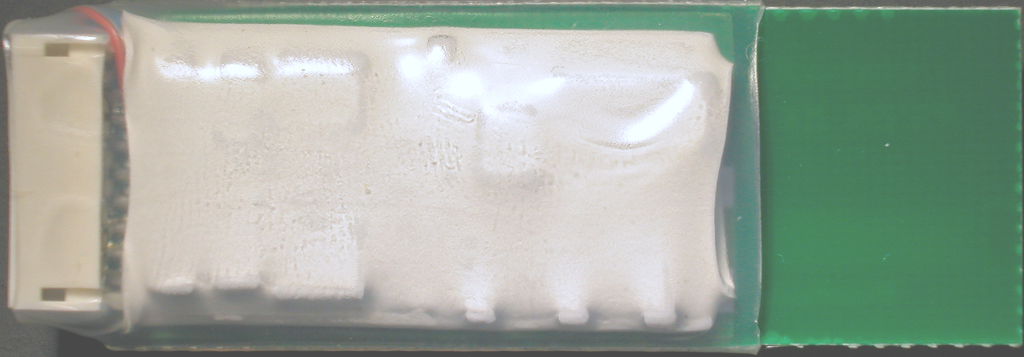
S-CAB requires a radio-ready decoder, which is an S-CAB compatible radio receiver combined with a standard DCC decoder. The starter package uses an NCE D13SR or D13SRJ decoder and consists of two circuit boards back-to-back in one package.
One side is NCE’s D13SR or D13SRJ (illustrated above).
Other side is the radio receiver and it’s antenna.
The rest of this Quick Start Guide assumes use of the D13SR converted for S-CAB radio compatibility.

Preparing to test the decoder:
- Read the decoder’s installation notes. (You can get these by going to NCE’s Web site [www.ncedcc.com] and locating their D13SR decoder.)
- Connect a motor to the orange and gray wires.
- If desired, connect lights using the white, yellow and blue wires. If you use LEDs, don’t forget to connect a 1,000 ohm (1K) resistor to one leg of the LED to limit its current. Either leg is okay. The longer leg is positive.
- Connect power supply to red and black wires (for example, one rail to red and the other rail to black). The choice of power type is not restricted. It can DC (track or battery), or DCC so long as the voltage is in the 9 to 15 volt range. The decoder works as low as 6 volts.
- Turn on power. The motor may or may not run. Either result is okay at this point.

Operation

Speed control:
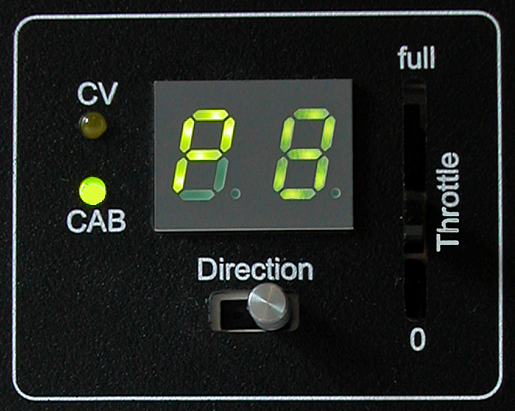
- Turn on S-CAB. If the throttle is zero, the display will show ‘L3’.
- Move the throttle from zero and S-CAB will display ‘P’ for power with a number, as you see in the photo to the left. Since the throttle provides 28 speed steps, values 10 and greater replace ‘P’ with the most significant digit of a 2-digit speed step (either ‘1’ or ‘2’).
Depending on the motor’s starting voltage, it may not start at ‘P1’ or ‘P2’, but it should definitely be spinning at throttle position ‘P8’. If you have adequate track voltage (12 volts) and the motor is not spinning, there is either a wiring problem or the motor has an undesirably high starting voltage.
If the motor runs, you can go ahead and install the decoder. However, there are some helpful steps you can take before installation, as well as some additional testing if you plan to operate loco lights or other functions.

Lights and direction control:
- Connect a light to white and blue wires, being sure to add a resistor in the circuit if using an LED. This will be the headlight.
- Connect a second light to yellow and blue wires. This will be the rear light. Because the blue wire is used for all loco functions, it is called “Light common” or “+ common”.
- Turn on decoder power. One of the lights may or may not turn on.
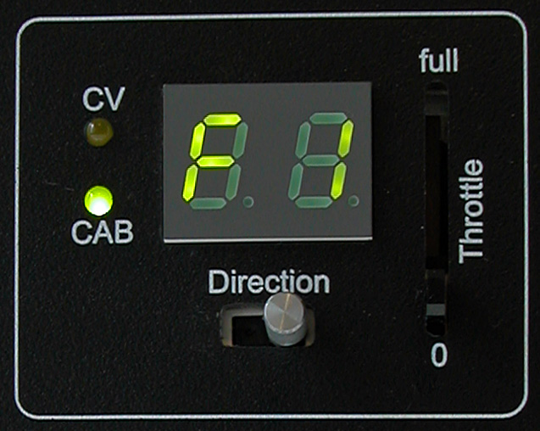
- Turn on S-CAB.
- Press and release the ‘FG1’ key. The display will show ‘F’ with blank.
- Press numeric key ‘1’ one or more times until one of the lights turns on. The display will show ‘F1”.
- Each time ‘1’ is pressed, the light toggles on and off. If the direction switch is to the right, as in the figure left, it will be the headlight that is switched on and off.
- With the headlight on, move the direction switch to its left. The headlight turns off and the rear light turns on.
This test is quite useful in determining how to connect the motor so that forward movement of the loco is consistent with headlight on. If not, now is a good time to reverse the motor connections and write a note to be sure it’s correctly wired when installed in the loco.

Change the decoder’s address:
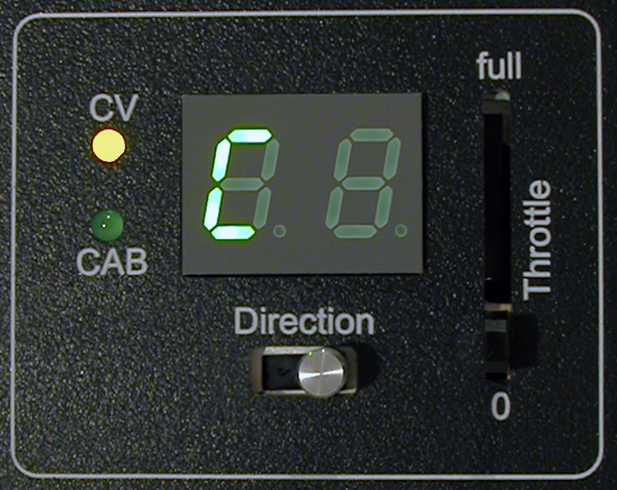
Independent control of two or more decoders requires that they have different addresses. So, if planning to install decoders in other locos, this is a good time to change the decoder’s address.
- Switch S-CAB off and back on. Make sure ‘L3’ is displayed.
- Move the Mode switch to its ‘CV’ position. The CAB light turns off, the CV light turns on and the display shows ‘C’ with blank second digit.
- Press the ‘C#’ key. It’s the same key as ‘FG1’, but it selects a CV number when S-CAB is in CV mode. The display shows ‘C1’, which is the CV number for the decoder’s short (primary) address and is the variable we want to change.
- Press the ‘C=’ key. S-CAB displays ‘U3’, where ‘3’ is the default address valUe, and is not what we want. (Note the prompt, ‘U’ for valUe.)
- Use the numeric keypad to select the address value we do want; number 8 for example. S-CAB displays ‘U8’.
- Press the ‘Enter/Send’ key. S-CAB display shows ‘L8’ and the motor connected to the decoder jerks a little to acknowledge that the address has been changed.
- Return the Mode switch to its ‘CAB’ position. The CV light turns off, CAB light turns on, and the display continues to show ‘L8’.
- Send a direction or speed command to the decoder to be sure it responds to commands sent to ‘8’; its new address.
- Now turn S-CAB off and back on and send a command. Since the decoder starts with default address ‘3’, the decoder will not respond.

Switching control between 2 or more decoders:
S-CAB is turned on and in ‘CAB’ mode, but the decoder now has address ‘8’, so how do we send commands to it?
- Press ‘Loco#’ key. The display shows ‘L3’.
- Press ‘8’.
- Press ‘Enter’. The display shows ‘L8’ and commands are now addressed to decoder number ‘8’.
S-CAB saves the state of all decoders to which it sends commands so that control can be switched back and forth between different decoders without loss of information.
For example, switching S-CAB back to address ‘3’, (key sequence; ‘Loco#’, ‘3’, ‘Send’) will not affect whatever speed and direction loco 8 is moving, but the loco will not receive any new commands until S-CAB is returned to address ‘8’.

End of Quick Start
Install the decoder and start operating with radio control. If loco performance is not what you expected or you want to see if improvements are possible, take a look at the next topic; “Tweaking loco performance”.

Tweaking Decoder Performance
If the decoder and motor parameters are nicely matched and the loco control performs to your satisfaction, don’t tweak. If the loco performed nicely before decoder installation and you are not satisfied with the way the decoder controls the loco, some tweaking will help. This requires use of S-CAB’s CV mode to change some decoder configuration variables.
The NMRA has defined a long list of decoder configuration variables (CVs), but decoder manufacturers are not obligated to support all CVs. NCE’s D13SR installation note includes a list of that decoder’s configuration variables (CVs). Of the many CVs defined by NMRA, the S-CAB allows 8 to be changed and 7 of these are applicable to the D13SR.
If you changed the decoder’s address during Quick-Start, you have already changed CV#1. There are really only 4 other variables worth experimentation.

Let’s review the procedure:
- Switch S-CAB to CV mode.
- Review operation of the ‘C#’ key. Press it once, then again, and again while watching the display. Each press and release of ‘C#’ steps to the next CV in the sequence; 1, 2, 3, 4, 5, 6, 29, 65, and then repeats. These CVs, listed in the table below, are the only CVs that can be edited with the radio CAB.
CV# | Description | Entry Format
CV1 | Primary address | 1 or 2 digit number
CV2 | Starting voltage | % full voltage
CV3 | Acceleration rate | 1 or 2 digit number
CV4 | Deceleration rate | 1 or 2 digit number
CV5 | Maximum voltage | % full voltage
CV6 | Mid voltage | 0
CV29 | Decoder configuration | 0 or 1
CV65 | Kick start | 1 or 2 digit number

- Review operation of the ‘C=’ key. With a CV number already selected, press ‘C=’ and the display will show a default value for the CV. For example, S-CAB suggests 90 (meaning 90% of full motor voltage) as a default choice for CV#5, which means the decoder will use 90% of maximum motor voltage at speed step 28.
- Either keep the default value or use the numeric keypad to choose a different value.
- Press the ‘Enter/Send’ key to transmit the new value to the decoder.
- Switch back to CAB mode and see how the loco performs. Continue this trial and error process until satisfied.

Change motor starting voltage:
- Select the loco and make sure it’s receiving control commands.
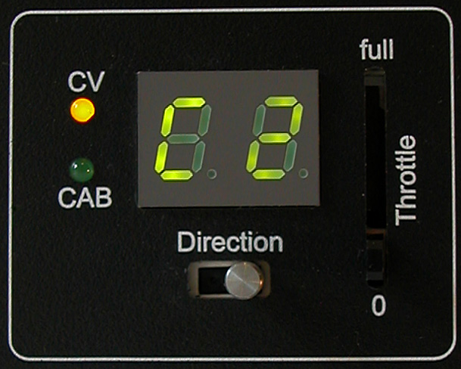
- Switch S-CAB to CV mode. The CAB light turns off, the CV light turns on and the display shows ‘C’ with blank second digit.
- Press the ‘C#’ key twice. S-CAB displays ‘C2’, meaning that CV#2 is selected. Since this CV defines starting voltage, it is the CV we want to adjust.

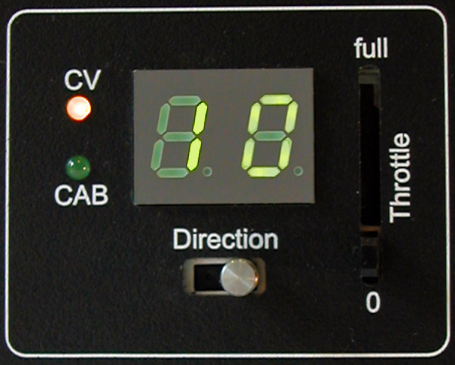
- Press the ‘C=’ key. S-CAB displays ‘10’, meaning 10% of full voltage for speed step 1, It’s a good value as a first choice. If you are repeating this process to choose a better value, use the numeric keypad to set the value smaller or greater than 10.

- Press ‘Enter’ to send the command and watch for a slight jerk of the loco as the decoder acknowledges the command.

- Switch back to CAB mode. Try starting the loco on speed step 1 to see how it behaves. It should barely move. At step 2, it should crawl along nicely. Remember, the decoder provides 28 speed steps, so the first couple of steps don’t need to produce large speed changes.
- If not satisfied, repeat the process, using a smaller value if the loco starts with an unrealistic jerk or increasing the value if the loco does not move on speed step 1 or 2.

Change loco acceleration or braking:
For acceleration, change the value of CV#3 as follows.
- Switch to CV mode
- Press ‘C#’ 3 times to display ‘C3’
- Press ‘C=’. The display shows ‘U4’
- If you want more momentum (slower acceleration), enter a number greater than 4. For no momentum, enter 0.
- Press ‘Enter/Send’ to transmit the value of CV#3 to the decoder.
- Switch back to CAB mode and see how the loco accelerates in response to speed commands
For braking, change the value of CV#4.

Charging S-CAB’s Battery
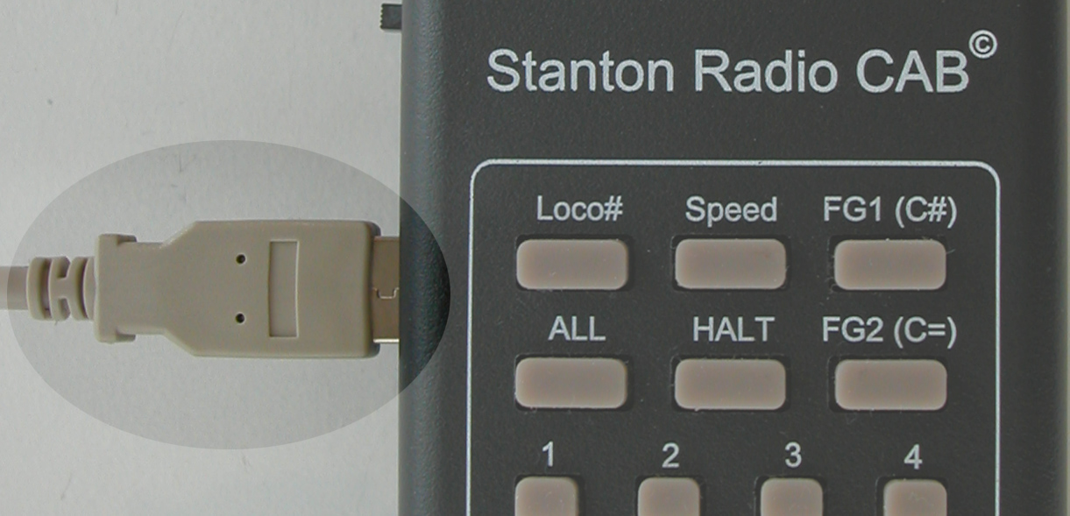
The display’s brightness is the first indication to recharge the battery. The battery’s protective circuit will automatically shut off to protect the battery against over-discharge.
Use the USB socket, left side of the CAB to re-charge the battery.

