RB02 / RPT1
Wireless base station and Repeater Manual

Version 1.0
Operate your cabs without plugging in

Features:
Second Generation two way wireless for DCC
Handles up to 48 wireless cabs.
Use up to 30 repeaters with one base station
Two way communication with the cab
All features of your Cabs are available without plugging in
Just plug it in - no soldering!
Cabs automatically switch over to bus power when plugged in

No guarantees are made by NCE or authorized NCE dealers as to the suitability of this product for its intended
use. As with all radio products, communication integrity in the presence of interference can not be guaranteed.

This book, schematics, drawings and artwork copyright 2005
NCE Corporation Webster, NY 14580
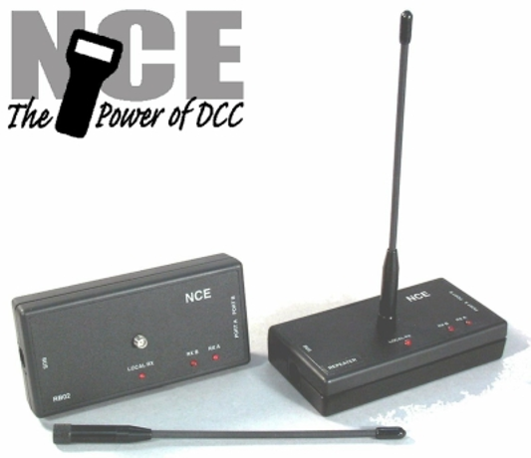
Page 2
RB02
RB02/RPT1

If you have received the RB02 as part of a complete NCE DCC system:
Setup and run the system without the wireless connected following the Quick Start guide in
your system manual. When you have confidence that all is working properly at that level then
proceed with connection of the radio.

About the NCE Second generation wireless:
The RB02 and RPT1 are NCE’s second generation two-way radio system for NCE wireless
throttle operation. The RB02 (Radio Base station) is designed to work with NCE wireless
cabs to eliminate the need for tethered operation. Only one RB02 may be connected to your
DCC system. In many cases the RB02 alone is sufficient to cover most layouts.

If you need to cover more area than the RB02 alone can provide you may add up to 30 RPT1
(RePeaTers). Repeaters are slave radio transmitter/receivers that work under the control of
the RB02. The RB02 has two expansion ports (PORT A and PORT B). You may plug a
repeater into either port or both ports. The RB02 can directly handle 2 repeaters. Each
repeater has two expansion ports (also labeled PORT A and PORT B). These ports are also
designed to accept repeaters. You may daisy chain repeaters up to 4 levels “deep” in each
chain. Addition of repeaters is discussed in more detail later in this manual.

If you have purchased repeaters along with your RB02 we suggest starting with just the RB02
Hookup and Quick Start below. As you gain familiarity with the radio operation then proceed
to add the repeaters.

RB02 hookup diagram

Cab Bus

NCE Power Pro
or Power Cab
UTP

RB02 Hookup:
1- Thread the included antenna to the mating connector on top of the RB02.
2- Connect the included 6 wire cable from the “Bus” connector on the RB02 to a convenient
Cab Bus connection on your layout (a UTP panel is shown as the connection point
above).

Quick Start for radio operation:
1- Make sure the DCC system is on.
2- Make sure your wireless equipped cab is setup in the proper address range (wireless
ProCabs use addresses 2-17, wireless small cabs use addresses 19-49).
3- Make sure your wireless cab has fresh, correctly installed batteries and the antenna is
attached
4- On the ProCab press EMERGENCY STOP (HORN on small cabs) until the cab powers
up. If you have trouble turning on the ProCab try pushing ENTER at the same time as
EMERGENCY STOP. The LCD on the ProCab will then briefly display the cab version
number and cab address just as when plugging it in to the cab bus. Then it will display
the software version and Layout ID of the radio in the cab. With smaller cabs the “Data
Entry” LED on the front of the cab will briefly light.
5- If all is working properly you should see a steady ‘heartbeat’ pulsing of the red light on top
of the cab. This light flashes every time the cab responds to a probe from the radio base
station. On the ProCab your normal operating screens should be displayed on the LCD.
On smaller cabs the red LED on the front of the cab should briefly light when a key is
pressed.
6- Enjoy your wireless operation

See the “Tips” section later in this manual for more radio operating tips.

**Last revised: 8 June 2005

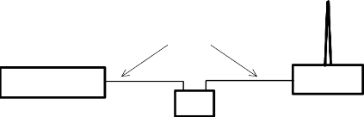
Antenna Radiation Patterns
from RB02 or RPT1 when using
the supplied 1/2 wave antenna
Page 3
RB02/RPT1

Wireless communications:
The transmitter power of the RB02 and RPT1 is .00035 Watts. By contrast your cell phone
can put out 3 Watts or roughly 10,000 times the power. We are continuously asked about the
operating distance of the wireless cab. There are many factors governing the useful range of
wireless products. The RB02/RPT1 operates in the ISM (Industrial, Scientific and Medical)
radio band at 916.5 Megahertz (MHz). Many cordless phones, wireless computer networks,
home automation systems, and wireless security devices also operate in this portion of the
radio band and all contribute to radio interference. Radio waves are like one big telephone
‘party line’ where everyone is talking at once. A device using these radio waves must attempt
to sort out what ‘voices’ are relevant to its operation and which ones are noise. If there is too
much noise it can’t do this successfully and will operate poorly or not at all.

Indoor radio propagation is an issue for special consideration. The human body readily
absorbs radio energy in the frequency band used by the cab radios. Placement of the base
station and repeaters can mitigate blocking of the radio signal due to human body absorption.
In most indoor situations ‘dead spots’ can be found where reception is very difficult. These
can occur even if there appears to be a direct line of sight between the transmitter and
receiver. These dead spots, or ‘nulls’, are the result of multiple radio transmission paths
between two points caused by reflections off metal objects such as steel beams, screen wire,
concrete rebar, metal door and window frames, ceiling tile frames, model railroad track, etc.
Nulls occur where the path lengths differ by an odd ½ wavelength (about 6 inches at 900
MHz). Deep nulls are usually very localized and can be avoided by moving slightly, usually
only a few inches. We suggest adding one or more RPT1 repeaters if you experience severe
null areas on your layout.

Installation of the RB02:
Just plug it in to the NCE cab bus (read “RB02 Hookup” on previous page).

Radio power planning:
If you are planning to add repeaters make sure the Cab Bus jack you are using can provide
ample DC power for the RB02 and any repeaters. The RB02 needs 60mA (about 1/2 the
power of a standard ProCab) and each RPT1 requires 35mA (about 1/3 the power of a
ProCab) of DC power.

Example: An RB02 plus 5 RPT1 repeaters will draw the DC power equivalent of 2 ProCabs.
In this case if the current cab bus can handle two ProCabs plugged in at the point where you
want to connect the RB02 then you should be OK.

For installations involving more than 10 repeaters a UTP panel can be used to add power for
the repeaters. Contact the factory of specific directions on using the UTP to add radio DC
power.

RB02 Location:
We’ve found good operation can be achieved by placing the unit at about shoulder level.
We’ve also had success with placing the RB02 (or RPT1) upside down on the ceiling of the
layout room (7-10 feet high). This gets the antenna above the main body mass of operators
in the layout room so less of the radio signal will be blocked by humans. See the diagram
below for how the radio signal propagates from the antenna.

Side View

Top View
The pattern is a 'Torus' (donut) shape

**Last revised: 8 June 2005
This Document has been created with a trial version of deskUNPDF. To
purchase a copy of deskUNPDF and remove the trial restrictions, please visit
www.docudesk.com or email sales@docudesk.com for assistance.

