The HUB Division, NER, NMRA is working to add signals to our modular layout. We have now reached the stage of adding C/MRI boards to actual modules and testing. We used small “test” modules to demonstrate a method to allow arbitrary order of modules. We have now added C/MRI boards to all four corners modules and are testing by connecting them into a completed circle. As part of the earlier tests, we used NCE BD20 block detectors attached to an NCE AUI. These worked very well with reliable detection using either a 4.7K Ohm single axle wheel set or a pair of 10K axles. They also reliably detected using the wet finger test.
In the testing of the C/MRI SuperMini boards, we noticed that a surprising reduction in sensitivity occurred with the DB20s. We are wired as Home Wiring identical to the diagram 5-5 on page 5-9 of Volume 1 of the C/MRI Railroader’s Handbook. We tested the effect of loops in the BD20s. We went through this exercise because we noticed that with one loop we could only detect locomotives and that lighted passenger cars are freight cars with single 4,700 Ohm axles would not detect. With three loops both lighted passenger cars and locomotives detected but single axle freight cars still failed to detect. The “wet finger” test never detected.
We were surprised by this in that with the earlier DB20/AIU testing with the test modules we were able to detect both freight cars and the “wet finger.” We attached batteries to the BD20s so that we could see the on board LED. We noticed that if the logic lead was not connected to C/MRI boards we got detection with both freight cars and the “wet finger.” Based on this we attached an oscilloscope and recorded readings. An RRampmeter was used as a test locomotive load. The results are shown in the three tables below.
Baseline Voltage connected = 5.20v, unconnected = 5.74v
Loops | Connection State | Detection Test | Voltage seen | BD20 LED state
1 | Unconnected | RRampmeter | 0.30 | ON
1 | Unconnected | 4.7K axle | 0.36 | ON
1 | Unconnected | Wet Finger | 0.38 | ON
1 | Connected to C/MRI | RRampmeter | 0.56 | ON
1 | Connected to C/MRI | 4.7K axle | 4.62 | OFF
1 | Connected to C/MRI | Wet Finger | 3.64 | OFF

Baseline Voltage connected = 5.20v, unconnected = 5.74v
Loops | Connection State | Detection Test | Voltage seen | BD20 LED state
2 | Unconnected | RRampmeter | 0.30 | ON
2 | Unconnected | 4.7K axle | 0.36 | ON
2 | Unconnected | Wet Finger | 0.34 | ON
2 | Connected to C/MRI | RRampmeter | 0.56 | ON
2 | Connected to C/MRI | 4.7K axle | 4.00 | OFF
2 | Connected to C/MRI | Wet Finger | 2.80 | OFF

Baseline Voltage connected = 5.20v, unconnected = 5.74v
Loops | Connection State | Detection Test | Voltage seen | BD20 LED state
3 | Unconnected | RRampmeter | 0.30 | ON
3 | Unconnected | 4.7K axle | 0.32 | ON
3 | Unconnected | Wet Finger | 0.34 | ON
3 | Connected to C/MRI | RRampmeter | 0.56 | ON
3 | Connected to C/MRI | 4.7K axle | 2.66 | OFF
3 | Connected to C/MRI | Wet Finger | 1.96 | ON (Dim)

It appeared that the DB20s sensitivity was being “dampened” as a result of being connected to a C/MRI pin. We found this surprising as most of the online discussion seems to be around the topic of the sensitivity being too high and dealing with false detection. This is the exact opposite of the problem we were encountering. Of note, the Northern California and San Luis Obispo Free-Mo group reported the same issue. See page 5 in the following link. (www.garymgreen.com/Free-mo%20signal%20article.pdf) They noticed that DB20s attached to C/MRI boards were not sensitive enough to detect a DCC loco with a high-efficiency can motor that is stopped with no functions activated (e.g. the latest offerings from Atlas). We saw this as well.
We originally connected the DB20s to the layout using the standard wiring approach recommended in the DB20 Manual as shown in Figure 1 below. The tables above were compiled using this form of attachment.
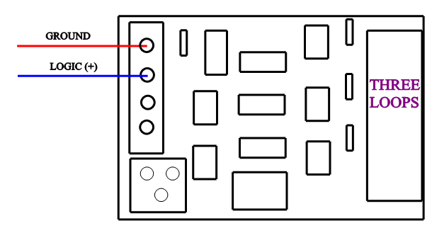
FIGURE 1.
However, the DB20 documentation also contains details the use of the two lower connections pins 3 & 4. These can be used to provide power to light an on-board LED that shows detection and to power output to an optional relay device. It appeared that these could be used to advantage for wiring the DB20 to a C/RMI board with enhanced sensitivity. We connected the same 5v power supply used to power the C/MRI board to the bottom connector (Pin4) and used the same ground as the power supply on Pin 1. Pin 3 was used to connect to the sensors on the C/MRI board. See Figure 2 below. Three loops were used around the transformer.
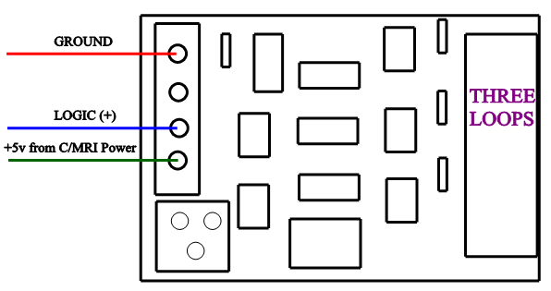
FIGURE 2.
Using this approach, BD20s with three loops provided very reliable detection of single axle cars with 4.7K Ohm resistors or trucks with both axles having 10K resistors. On the oscilloscope the voltage dropped all the way to ground with only 4.7K ohms as well as with the wet finger test. An added benefit of this wiring approach is that detection is also shown by the on-board LED on the DB20 illuminating when detection occurs. This is a simple wiring change that quite dramatically enhances sensitivity of DB20s when used with a C/MRI board.

