Power Cab

System Reference
Manual

Rev. 1.65

1
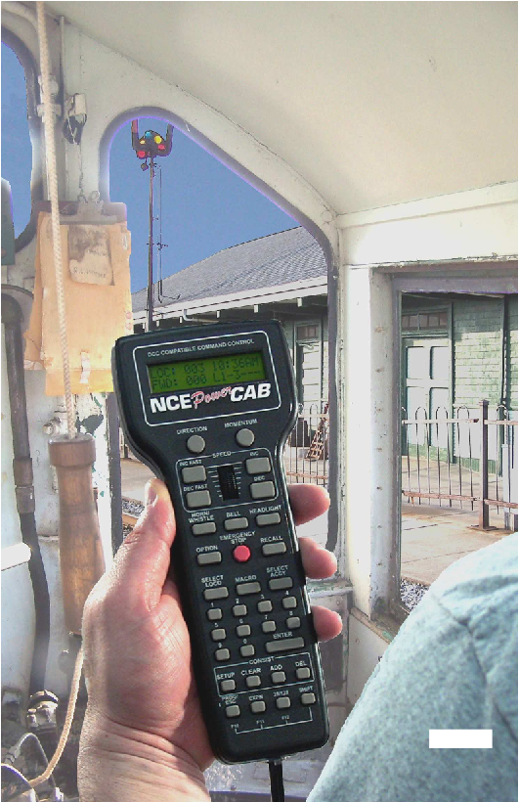

12:00AM
L1-3---
Power Supply
P114

LOC:1234
FWD: 000
NCE CAB

Optional Extra
Cab

Power Panel

Red LED on
bottom of panel

6 Wire FLAT
Cable

Basic Set Up of the
Power Cab System
Your Power CabTM is a full featured DCC system. It must be used with the 6 wire,
FLAT cable supplied. All features described in this manual are available to you when
used in the Power CabTM mode.
If you own or operate with a PowerHouseTM or Power ProTM NCE system, you can
use the Power CabTM as a Pro CabTM using the 4 wire coiled cord that is also supplied.
BE CAREFUL
An NCE P114 power supply (13.5VDC Regulated) is the supplied transformer for
your system.

2
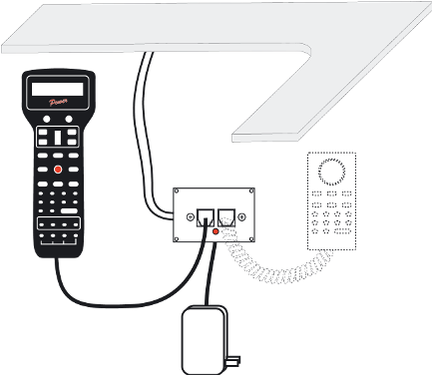


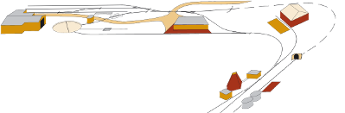
Power Panel (marked PCAB-PP)
Coil Cord (4 wire) to use as a Pro Cab
Power CabTM system reference manual
FWD: 000 -------
LOC: 003 00:03AM

Quick Start
Contents of the Power CabTM System:
Power CabTM
Seven foot flat cable
Power Supply

We recommend that you follow the instructions below to connect your system to a
small test track first. After your system is checked out completely and known to be
working then consider the final installation locations for components and connections
to the track.
TRYING OUT YOUR POWER CABTM:
#1 Assemble the Power Panel by screwing the black plate to the circuit board with
screws provided.
#2 Connect the long 7 foot flat cable from the Power CabTM into the socket marked
(on the drawing) POWER CABTM (left socket).
#3 Use a small, flat screw driver to attach the test track feeder wires to the small
two place connector. Make sure that there are no shorts or frayed wires between
the connections.
#4 If you have a locomotive with a DCC decoder already installed place it on the
track.
#5 Plug the power supply into the socket marked POWER. Plug the power supply
into a wall outlet.
#6 The display of the cab should look something like:

LOC: 003 00:03AM
FWD: 000 -------

This is what we call the ‘NORMAL DISPLAY’. The fast clock in the upper right hand
corner will most likely show a different time.

The following cab buttons must be pressed in the proper sequence to acquire control
of the locomotive #3 (in the above example locomotive #3 is already selected):

Note: By convention, locomotive decoders usually have their short address set to 3
at the factory.
a. Press SELECT LOCO button once.
b. Press the “3” button once. DO NOT press 0 then 3.
c. Press ENTER.

TIP #1 If you make a mistake while entering numbers on the cab just keep pressing
more numbers until the number entry field clears, then enter the correct numbers.
TIP #2 Whenever the cab is waiting for you to enter data (a flashing black square is
on the screen at the point where the numbers will go) you can press the PROG/ESC
key to “escape” what you were doing and return to normal operation mode.
TIP #3 Whenever you have pressed a button (such as SELECT LOCO) and you
want to keep what ever number that is already on the screen just press ENTER.
#7 To operate the locomotive, the following controls are used:
a. The thumbwheel will increase/decrease speed. The speed control buttons
that flank the thumbwheel on either side may also be used as desired to
control the loco speed.
b. Pressing the DIRECTION button will cause the loco direction to reverse.

CONGRATULATIONS! You are now operating a locomotive with DCC control. In
most cases, less than ten minutes has elapsed since you started reading this Quick
Start Guide.
3
This Document has been created with a trial version of deskUNPDF. To
purchase a copy of deskUNPDF and remove the trial restrictions, please visit
www.docudesk.com or email sales@docudesk.com for assistance.



