Introduction
This decoder Board is designed to control between 1 and 8 low current ‘stall motor’ switch machines, e.g. TortoiseTM, SwitchMasterTM. Each Output is rated for 40mA maximum. With normal input voltage (about 13-15 volts), most TortoiseTM machines draw 10 to 20mA. Each Output must have a unique Accessory Code in the range 1 to 2040.
The SW8.2 can do the same as the original SW8, plus use the optional ‘Button Board’ (see last page; thus no more mandatory M-P (Mini-Panel), Throttle, Programming jumper or PC. There are now 2 power choices and easier programming via a new status/address-code display.
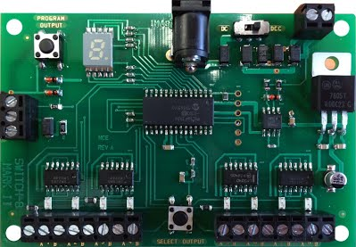
Wiring | 2 wires to the track (picture top-right) and 2 wires from each Output’s AB terminals (2 banks of 8 pairs along bottom) to each switch machine.  The 3-bank connector (on left) is for wiring (Data, +, Grnd) to the Control Panel’s optional ‘Button Board’ (see last page).
Never used a SW8.2 before? | Before installing it on a layout, via the 4 mounting holes at the corners, we recommend getting used to the SW8.2; follow the 4 Experience Steps:
Step 1: Connections | Connect a TortoiseTM machine to screw terminals 1A/1B of the SW8.2;  Make sure the small DC/DCC switch, next to the track connections, is moved to the ‘DCC’ position. For now, do not connect a DC power supply.  Connect two wires from the SW8.2’s track connections (top-right) to your DCC system.
Step 2: Switch-ON your DCC system | When you first apply power to the SW8.2, the address display will show some numbers (the software version), then 3 horizontal bars for about 1 second, followed by vertical bars ‘wig-wagging’ back & forth, indicating that the SW8.2 is receiving DCC information and is ready for use.
Step 3: Selecting an Output | On the SW8.2, press the ‘SELECT OUTPUT’ button until the output 1A/1B LED lights (each push of the button will select a different output - on the 9th push all LEDs will turn OFF). The address display will now start indicating the Output currently programmed, i.e. Output #1 will flash 1. If you select Output #2, it will flash 2, etc. up to 8. (These are the Factory defaults.)
Step 4: Test of Output #1 | DCC system Instructions for throwing a switch  NCE Press ‘SEL ACCY’ Type-in the desired accessory number followed by ‘ENTER’ Push ‘1’ (or ‘2’) to throw the switch.  Digitrax Press ‘SWCH’; Type-in the desired accessory number; Push ‘OPTN’ to throw the switch.  Lenz Press ‘F’ Press ‘5’ Type-in the desired accessory number followed by ‘ENTER’ Push ‘+’ (or ‘-‘).  If throwing the switch one way doesn’t do anything, try the other direction. You should be rewarded with the TortoiseTM reversing its position.
Address Programming | The SW8.2 can only be programmed while connected to the mainline track, not the programming track. This decoder can be programmed by all systems that support accessory control using the following procedure:  1) Connect wires from the track to the decoder DCC terminals.;  2) Make sure the DC/DCC ‘Power Select’ switch is set to DCC;  3) Push the ‘SELECT OUTPUT’ button until the LED corresponding to the required Output lights;  4) Push the ‘PROGRAM OUTPUT’ button (notice the display flashes ‘P’ now). When the display is flashing you have one minute to complete the next step, otherwise the decoder will exit programming mode;  5) Use your DCC system to select and operate the switch (see above);  6) The decoder will accept that switch address as its new address and begin showing its new address on the address display. It will show the address one digit at a time in sequence, e.g. 1 3 5.  You may confirm the address for any output at any time by pressing the ‘OUTPUT SELECT’ button until the appropriate output LED lights. The address for that Output will be displayed.
Programming CVs with systems that don’t support Accessory OPs mode programming | Press the ‘SELECT OUTPUT’ button on the SW8.2 until the button for Output #1 lights.  Press ‘PROGRAM OUTPUT’ (the display should start flashing ‘P’)  Use ‘Loco Ops’ mode programming (‘Program on the Main’) to program the desired CV. Any loco address can be used for this.  Repeat the steps above for each CV you wish to program.  If the programming ‘takes’ (is accepted) the display will stop flashing.  Note:  The display will flash for about 1 minute. When it stops flashing the SW8.2 will not accept programming. If it times-out and stops flashing before you finish programming, just press ‘PROGRAM OUTPUT’ again.  Note:  You can only program CVs using ‘Loco OPs mode’ when Output #1 is selected. If any other Output is selected, ‘Loco Ops’ will not work (only ‘Accessory Ops’ works with all Outputs).

Setting other options in the SW8.2
‘Accessory Ops’ mode programming | On NCE systems use ‘PROG’ followed by ‘7’. If you have an entry-level system that does not support ‘Accessory Ops’ mode programming follow the instructions on the back page for setting CVs with ‘Loco Ops’.  For CV561 through CV568 use the accessory address for the corresponding Output number.  For all other CVs, use the accessory address programmed for Output 1.
Reversing the polarity of an Output | Each of the Outputs can have its polarity reversed by programming the Output’s CV, 0 (default) for normal polarity, 1 for reverse:  Output #1 #2 #3 #4 #5 #6 #7 #8  CV 561 562 563 564 565 566 567 568  If your DCC system does not support ‘OPs Mode’ programming for accessories, just swap the two wires to the switch machine.
Setting Outputs to toggle when used with optional ‘Button Board’ | Setting CV548 = 1 will cause each push-button connected via the ‘Button Board’ to ‘toggle’ the switch machine output, i.e. each press of one button will alternate the switch’s position. Thus only 8 push-buttons are needed; each is connected to an ‘N’ terminal, so less wires in the control panel.  Setting CV548 = 0 disables it. (Factory default = 0).  CV548 is ‘global’ to each SW8.2, meaning it will affect all button commands coming from it’s connected ‘Button Board’.
Push-button Lockout (CV556) | On some layouts it may be desirable to disable operation of the ‘Button Board’ push-buttons.  CV556 = 0 enables operation of these buttons; 1 prevents operation of all the decoder outputs. (Factory default = 0).  CV556 is ‘global’ to each SW8.2, meaning it will affect all button inputs from it’s connected ‘Button Board’.  You can disable or enable ALL decoders on the layout at the same time by using the accessory decoder broadcast address of 2044.
Reset to Factory settings | To the address of Output 1, via ‘Accessory Ops’ mode programming, program CV8 = 8.  This will reset the whole SW8.2 .
Factory default values for decoder | The SW8.2 is factory-programmed to the following values:  Output #1 #2 Etc.  Accessory address 1 2 Etc.  CV548 is set to 0 (normal dual push operation by the ‘Button Board’).  CV556 is set to 0 (push-button lockout not engaged).  CV561 to CV568 are all set to 0 (normal output polarity).

Other Technical stuff
External DC Power | If you wish to use external DC power (between 8 and 15V) to run the decoder and switch machines, a DC power connector is provided. Use a 2.5/5.5mm plug (center positive).  Remember to move the DC/DCC ‘Power Select’ switch to the DC position.
With DC Power AND a ‘Button Board’ | DCC Accessory commands from the DCC system controller, via the track bus into the SW8.2’s built-in optical isolator. The best of Push-Button and Controller; and if the DCC bus has a short-circuit, the push-buttons still work.
Address Display | 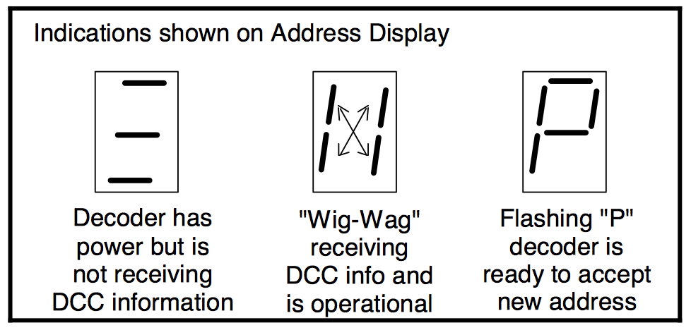
2 Switch Machines per Output | We have successfully controlled two Tortoise switch machines with one decoder output when used in a crossover. We can't guarantee this will work in all cases.
Decoder Outputs | These are always ON, to prevent the switch machine from backing-off due to the spring pressure of the turnout throw mechanism.

More Tips
Switch Machine Mounting | On our TortoiseTM machines we use low temperature hot glue to mount the machine. The glue stays liquid just long enough after application to allow alignment of the machine.  To give you space to put glue on the machine, after the wire is put through the roadbed, use a throw wire that is about 6” (150mm) longer than the one provided with the TortoiseTM.  We manually center the machine’s arm, then slide the machine around while the glue sets to align the points to the middle of their throw.  The glue is weak enough to allow removal of the machine later, by gently prying with a putty knife.
Turnout (Point) Position Indicator Lights | LEDs can be wired in series with the switch machine, to indicate which position the turnout is thrown (see below). Most LEDs will handle up to 20mA, the switch motor acts as the current limiting device for the LEDs.  We use red and green LEDs but any color will do.  With about 1.5 volt loss in the LEDs, the switch machine will run a bit slower.  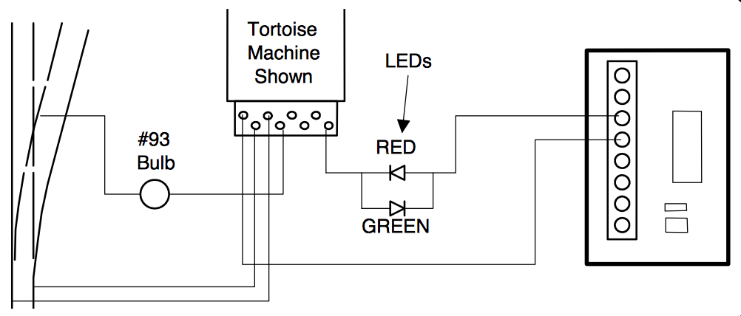
Powering the Turnout’s Frog | If you use the TortoiseTM contacts to power the turnout’s frog, we suggest wiring an automotive bulb #93 (other useful bulbs #211, #305) in series with the frog (see below).  This will prevent short circuits from shutting-down the power booster in the event a loco enters the turnout from the frog end without aligning the points. For ‘O’ and larger scales use a #1156 bulb.

Optional ‘Button Board’ (NCE available part 524-152)
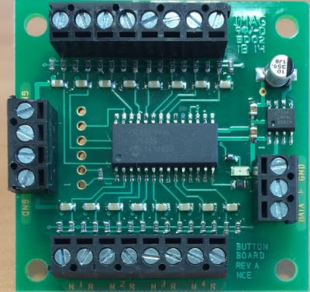
NCE’s ‘Button Board’, placed in a control panel, allows connection to a nearby SW8.2 for control of turnouts; this is done using either N.O. (Normally Open) toggle switches (momentary or non-momentary) or push-buttons.
Three small gauge wires (recommended #22-#26 AWG) will connect the ‘Button Board’ to the SW8.2; ‘DATA’ terminal on the ‘Button Board’ to the ‘DATA’ terminal on the SW8.2; ‘+’ to ‘+’; and ‘GND’ to ‘GND’. These wires supply the power and issue commands to the SW8.2 .
Grounding terminal 1N of the ‘Button Board’ will activate Output #1 of the SW8.2 to the ‘normal’ position. Grounding 1R will throw the SW8.2 to the ‘reverse’ position. The other ‘Button Board’ terminals work similarly to activate the corresponding SW8.2 Outputs.
The diagram overleaf shows a mix of 1 toggle switch or 2 push-buttons per Output; however, by programming CV548 = 1, only 1 push-button is needed per Output – with this CV setting one can only use 1 to 8 push-buttons, not a mix with toggle switches.
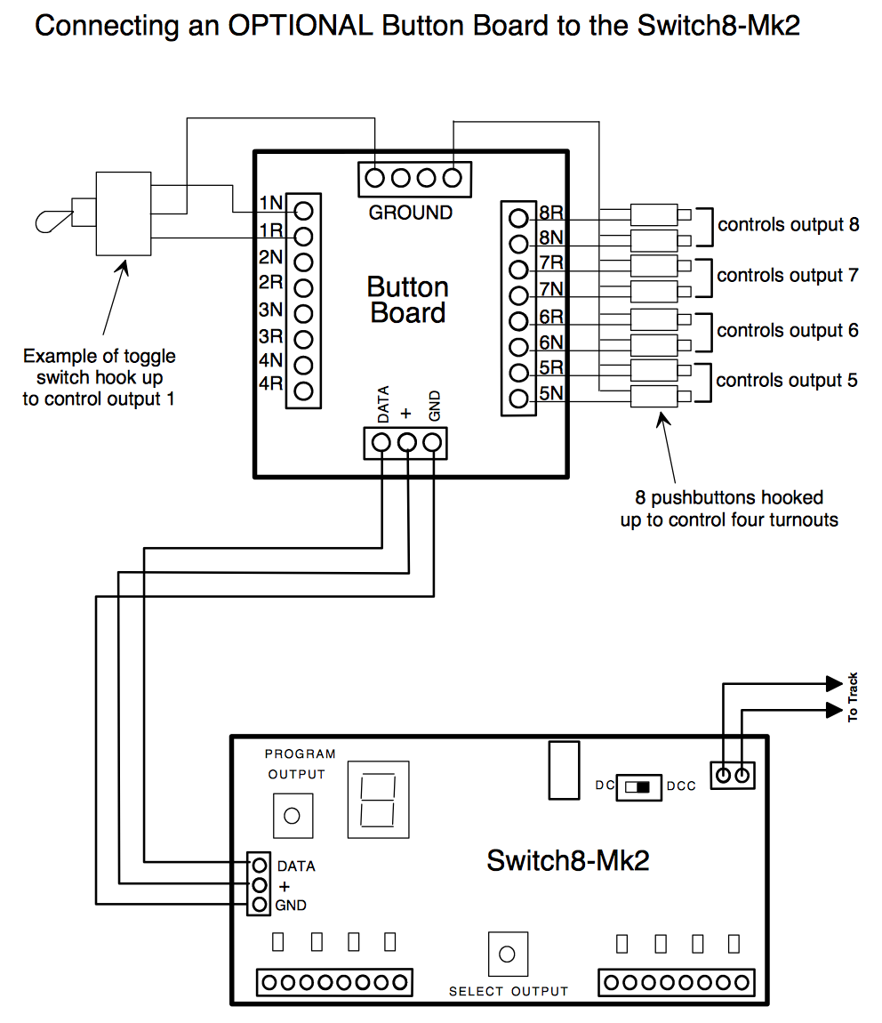

The warranty is voided if the decoder is mis-wired, connected to more than 22 volts, or used with switch motors drawing more than 40mA.
Warranty
This decoder is fully factory tested and warranted against manufacturing defects for a period of 1 year. As the circumstances under which this decoder is installed can not be controlled, failure of the decoder due to installation problems can not be warranted. This includes misuse, mis-wiring, operation under loads beyond the design range of the decoder or short circuits. If the decoder fails for non-warranted reasons NCE will replace the decoder, no questions asked, for $20 US plus $2 shipping. For warranty or non-warranty replacement send the decoder (an any payment, if required) to:
NCE Warranty Center, 82 East Main Street, Webster, New York 14580
<bar code>
05240151
The terms Power Pro, ProCab, Power Cab, the NCE logo with ‘Power of DCC’ slogan and the distinctive shape of the ProCab with thumbwheel and LCD are trademarks of NCE Corporation. Digitrax is a trademark of Digitrax Inc.

