Cab Bus Fascia Panel
Model # UTP
NCE Corporation
82 East Main St.
Webster, NY 14580
FRONT
REAR
The UTP cab bus panel provides a low cost means of adding walk around capability to your layout.

The panel has 4 RJ-12 connectors wired in parallel, two on the front and two on the rear. Your cab bus can be “daisy chained” from one panel to the next using the rear connectors. One or two cabs can then be plugged in to the front connectors. Please note the “Command Station” side versus the “More UTP panels” side in Figure 1 when wiring your panels.
Figure 1 Connection of multiple UTPs
From Command Station
To more
UTP Panels
PROPER CAB BUS CABLING
The cables that connect the command station to the UTP and from UTP to UTP must be wired “straight through” meaning Pin 1 of one connector must be connected to Pin 1 of the other connector (see figure 2). Please note that this is not the normal telephone cable wiring.
Proper orientation of the RJ-12 connectors on cab bus cables

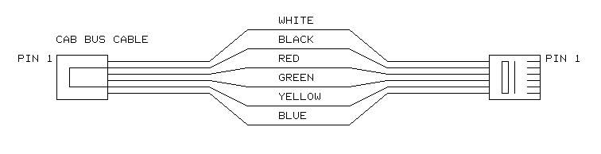
Figure 2 Correct wiring of RJ-12 Cable
The normal wire gauge for RJ-12 cables is #28 or #26. This wire size is sufficient for cab bus lengths of up to about 30 or 40 feet (10-13 meters). If your layout requires a cab bus longer than this we suggest adding extra power to the bus at about 30 foot intervals. This is easily done by plugging a DC power supply in to the 1/8 inch (3.5mm) plug on the back of the UTP. The tip of the plug is positive (+) and the sleeve is negative. We recommend a “wall wart” (the black box that hangs on your wall outlet) type supply in the range of 12 to 14 volts DC with a capability of ½ to 1 Amp. These supplies are easily found at Radio Shack .

INSTALLING AN LED AS A TRACK STATUS LIGHT
If you wish an LED can be installed between the two front RJ-12 connectors on the panel to serve as a track status light. We recommend using a T1 sized (.100 inch diameter) bi-color LED. Solder the LED to the bottom of the PC board. Leave enough lead length to bend the LED over and fit it through the hole in the front panel. You will also need to solder a 1K ¼ watt resistor in the two holes marked “1K”. Connect the panel to the track using the two holes provided at the back of the PC board marked LED- and LED+. If you don’t want to solder wires to the panel the PC board holes are sized to accept up to #4 screws. Ignore the polarity markings if using a bi-color LED.

INSTALLING AN LED AS A PANEL LOCATOR LIGHT
You may wish to install an LED on the UTP panel to help operators to find the panel darkened or dimly lit rooms. Conventional T1 sized red, green or yellow LED can be used. Solder the LED to the bottom of the PC board. Leave enough lead length to bend the LED over and insert it through the hole in the front panel. Be sure to solder the shorter lead (cathode) of the LED in to the square hole. You will also need to solder a 1K ¼ watt resistor in the two holes marked “1K”.

Powering the panel locator LED from cab bus power
If you wish to power the LED from the cab bus power, jumper a small wire from the hole marked “+” to the holes marked “LED+”. Similarly add a small jumper wire from the holes marked “LED-“ to the hole next to the one marked “+”.

Powering the panel locator LED from external power
If you wish to power the LED from an external source connect the holes marked LED+ and LED- to the + and - terminals of a 5-15 volt DC power supply.

A front panel plate and two #6 screws for attaching it to the UTP printed circuit board are supplied. Note that if you want the LED at the top of the panel you should install the UTP “upside down”. This will also keep dust from building on (and inside) the RJ-12 connectors

